Note: Include this page only when adding / amending / deleting a document. If using this document as a record, this Revision History page can be omitted.

REVISION HISTORY

Revision no | Date | Description of Changes | Reason for Revision | Revised by | Approvedby
1 | 20 Jun 12 | Add revision history page | Recommendation from Stage 2 audit | CMRojas
2 | 24 Aug 12 | Add when to conduct business planning | Define when to conduct business planning | ECVentura | ECVentura
3 | 9 Nov 15 | - Added Disclaimer | - Printing is sole responsibility of the person who printed it | RCGanal | ECVentura

- Objective

To develop an annual business plan that will set the strategic direction, the company’s goals and objectives and lay out the operational, quality management and tactical plans that when followed should enable the company to meet its targets.

- Scope
- Defines flow of steps of the Execom and unit heads in the development of the Business Plan
- Includes the analysis of historical performance data and external information
- Ends with the consolidation and finalization of the Business Plan Document with approved action plan inputs from the different units

- Definition of Terms

None

- Procedure Details

RESPONSIBLE | ACTIVITY | INTERFACE
Execom  Unit Heads | 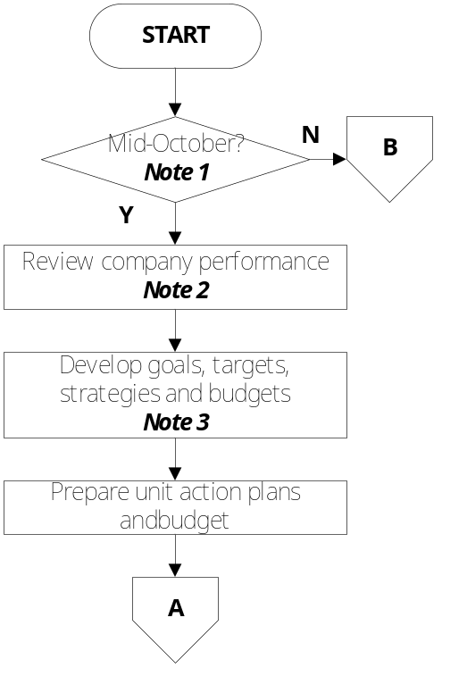 | Financial Reports  KPM Reports  Financial forecasts  and budget for  following year  Business Plan Draft  Unit Action Plan (attachment of Business Plan)

RESPONSIBLE | ACTIVITY | INTERFACE
Execom  Unit Heads  Execom | 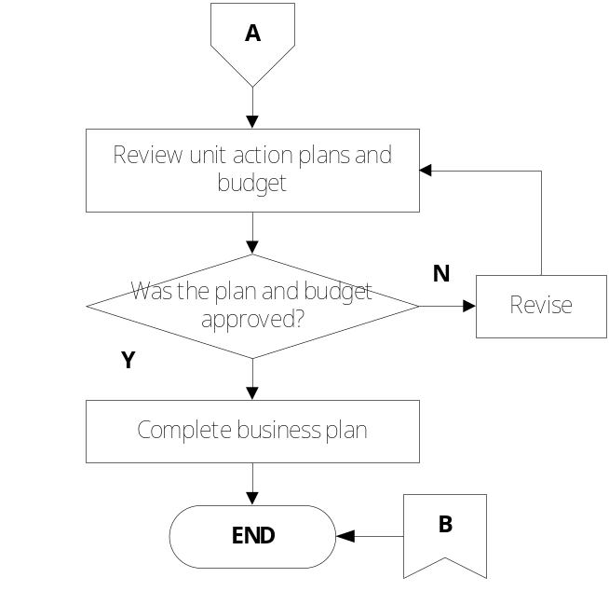 | Business Plan (Final)

Notes:

- Conduct business planning every mid-October. Business Plan should be completed by mid-December.

- The following information will be used to review company performance:
      - Financial performance data
      - Non-financial performance data such as accomplishment of key performance measurements
      - Attainment of quality objectives

3. The following external data will also be obtained as input to goal and strategy development
- market research
- relevant economic data
- environment scan
- info on competitors
- info on organizations (trade/ industry/government/ academe)

- References
- Business Plan Template

- Quality Record
- Business Plan

